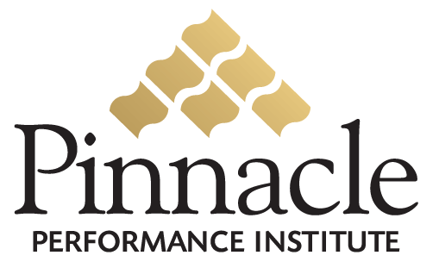

Sales Management Bonuses

Training Bonus
Account Executives have the opportunity to train and support Sales Affiliates for which they will receive a 5% Training Bonus on the Affiliate’s sales until the Sales Affiliate qualifies as an Account Executive.
Executive Bonus
Manager
An Account Executive that develops an Account Executive qualifies as a Manager and earns a 10% Management Bonus on the new Account Executive’s monthly sales volume.
Sr. Manager
A Manager that develops a Manager qualifies as a Sr. Manager and earns a 5% Management Bonus on the Manager’s monthly sales volume.
Director
A Sr. Manager that develops a Sr. Manager qualifies as a Director and earns a 5% Management Bonus on the Sr. Manager’s monthly sales volume.

Sales Management Bonuses

 |  | Bonus
 | Trainer | 5%
 | Manager | 10%
 | Sr. Manager | 5%
 | Director | 5%

